The “Word Web” (Visual Learning)
​Center: Write the “New Word” (e.g., Triumphantly).
​Top Left: Write the definition in their own words.
​Top Right: Draw a small picture of the word.
​Bottom Left: Write a synonym (a word that means the same).
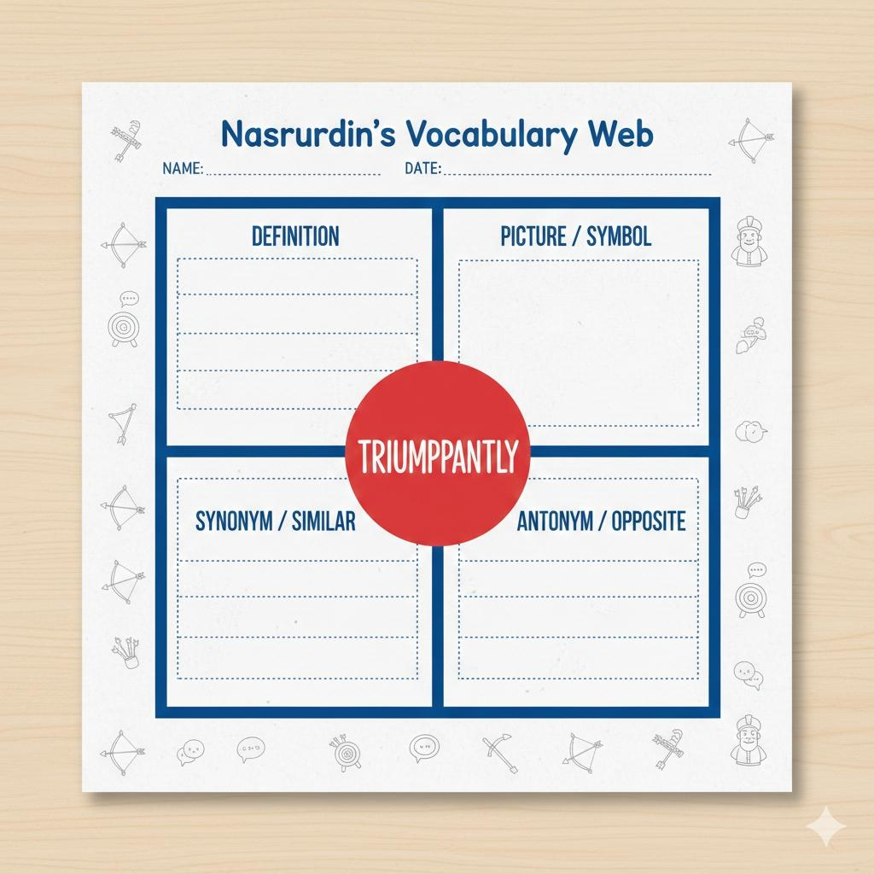
​Bottom Right: Write an antonym (a word that means the opposite).

Story Challenge
Nasruddin was __________ with his neighbor when he saw a wooden post. “Look!” he cried, “I am a master of __________.” He grabbed a bow and pulled the __________ back as far as it would go.
​Whosh! The arrow flew into a tree instead. Nasruddin began __________ himself immediately. “That wasn’t my shot! That was how a sleepy person shoots!”
​He tried again. This time, the arrow hit the __________ perfectly. Nasruddin stood __________ and looked at his neighbor. The neighbor’s mouth was __________ in surprise!

